SQL Learning



Nithish Gowda

26-05-2025

What is SQL?   
SQL (structured Query Language) is a programming language used to interact with databases.  
It is the standard language for querying, inserting ,updating,and managing data stored in relational databases.   
  
Why we use SQL?  
1. Simplifies working with large datasets.  
2. Enables easy and efficient data management.  
3. SQL is universal and work with most database systems ( like PostgreSQL,MySQL, SQL Server)

SQL used in following job roles of data field?  
Data Scientist, Data Analyst, Data Engineer, SQL Developer, Business Analyst , Quality Analyst.  
  
What is DATA ?  
1. Anything and everything can be considered as data.

1. Any information or fact can be considered as data.
2. For any financial institute, details related to its employees, customers, their services or even their address can be data.
3. Data can be in any form such as text message or an image or a video or a document or singke character itself.  
     
   What is Data Base?  
   A Data Base is collection of data that can be easily accessed digitally.  
   A software to manage database is called DBMS(Database Management Software).  
   Ex: School DB, Bank DB,   
     
   Purpose of storing Data in the database is : Easily Accessed, Modified, Protected, Analyzed.  
     
   Table Structure and it value :   
     
   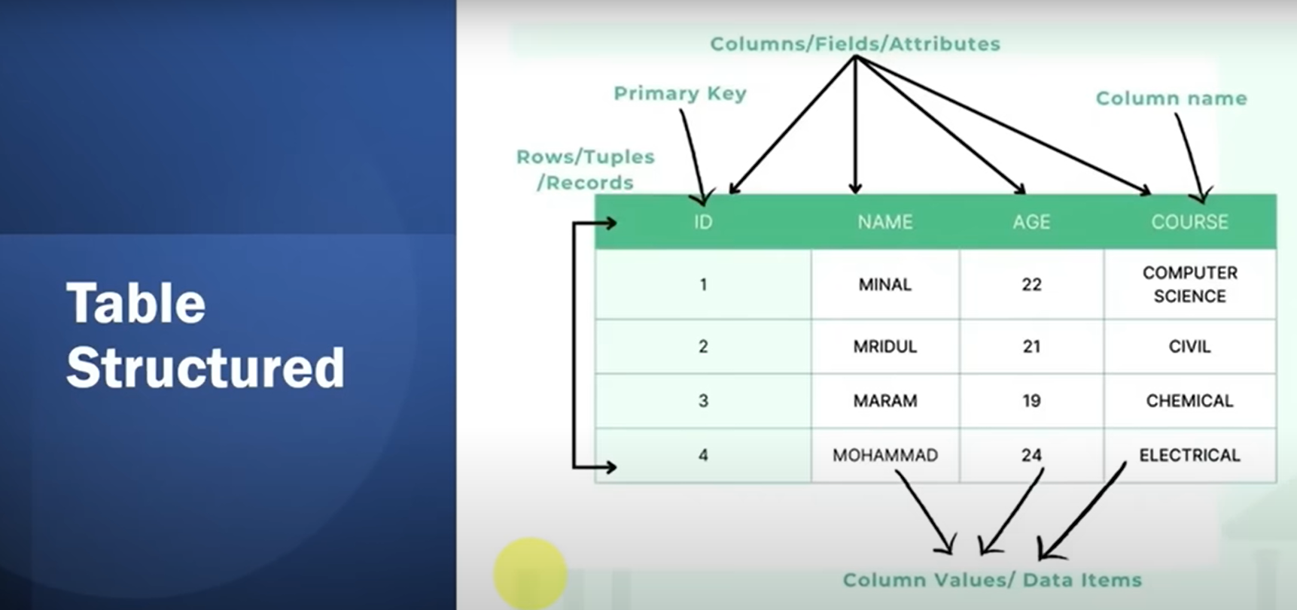  
     
     
   Ex OF RDBMS : Oracle, SQL Server, PostGre SQL, MySQL.  
     
   So **in this journey im learning “POSTGRE SQL”,**Download and Install Postgre SQL via official website.